

Story 2

Loss during transport

Version 0.1

15.11.2005

Your partner to set your business into real-time

Table of contents

Story 2 1
Table of figures 2
1 Starting point 3
2 Preparation 3
3 The Transport 4
4 Acceptance of Shipment 4
5 Conclusion 4

Table of figures

Figure 1: Eventdiagram 5
Figure 2: Storyline 6

- Starting point
In Vienna there is a demand of 400 units “Tosalumn” and 1000 units “Zatanol” on November 22, 2005, which can’t be satisfied by the current stock of the local depot.

For this reason Vienna asks on November 11, 2005 for a shipment of these two products until not later than November 21, 2005, because all delivered units have to go through some time-intensive quality tests.

In Paris the order is checked in and accepted as OrderId 15328. Paris takes care of the next steps to fulfil the order accurately. (OrderReceived, OrderConfirmed)
- Preparation

In a first step, Paris starts on Friday, November 11, 2005 afternoon to enquire which carrier is able to transport the products under the following constraints: (ShipmentTenderIssued):

- Departure from depot Paris on November 15, 2005 08:30, which is the earliest date, the products are available.
- Arrival at central storage depot Vienna until not later than November 21, 2005 07:00
- Price lower or equal to 2040EUR

Additionally both products need special treatment during shipment: to ensure the full quality of the product “Tosalumn”, it has to be kept in a temperature interval between -10°C and -2°C, whereas “Zatanol” has to be kept between 5°C and 9°C. To fulfil the shipment in a single Truck, for reasons of economy, a special truck is needed with two separated freezers.

The carriers Anger(532) and Fischer(142) reject the transport immediately on Friday, November 11. In the morning of November 14, 2005 carrier Weiss(433) also declines, however Panner(432) accepts the shipment under the given constraints. (ShipmentTenderRejected, ShipmentTenderAccepted)

A schedule for the shipment is created together with carrier Panner. The shipment will take three stages: Stage 1 from Paris to Frankfurt. Stage 2 from Frankfurt to Munich, and stage 3 from Munich to Vienna. The transport should start in Paris at November 15, 2005 08:30 and is planned to arrive in Vienna on November 16, 2005 19:30. Latest Buffer for arrival in Vienna is November 21, 2005 07:00 to be able to satisfy the demand on November 22, 2005 and to run all required tests with the delivery. (ShipmentCreated)
It is necessary to monitor both products’ temperature during the whole transport. For this reason two dataloggers per product are configured to protocol the current temperature every 30 minutes. The dataloggers are packed together with the products to determine the values as exact as possible. (DataLoggerConfigured)
- The Transport
On November 15, 2005 09:30 the transport goes out with a delay of one hour from depot Paris. The destination of stage 1, Frankfurt, is reached at 17:41. (ShipmentStarted, TransportStart, TransportEnd)

The products are handed over to the carrier’s depot in Frankfurt. Dataloggers are checked and the shipment is audited for its completeness. The values are sent into the system, where they are recognized as valid values. (DataLoggerRead, ShipmentAudit)

On November 16, 2005 06:03 carrier Panner continues the transport and starts stage 2 from Frankfurt to Munich. Munich is reached at 11:17, where the products have to be reloaded into an other truck for the 3rd stage. (TransportStart, TransportEnd)

The dataloggers are evaluated successfully, but when auditing the products suddenly only 297 units of “Tosalumn” are found. (DataLoggerRead, ShipmentAudit)

The system recognizes the loss of 103 units of “Tosalumn” and reacts: Until November 21, 2005 07:00 103 units of “Tosalumn” must be shipped to Vienna additionally, to satisfy the demand on November 22. A staff member is instructed to contact the carrier’s depot in Frankfurt, where the missing units have been seen the last time. If they can’t be found there, a new order with 103 units of “Tosalumn” to Vienna must be triggered.

At 11:49 the current transport is continued anyway and reaches its final destination Vienna at November 16, 2005 19:38.
- Acceptance of Shipment
The datalogger are read in Vienna, and return valid values also for stage 3. The shipment audit again gives 1000 unit for “Zatanol” and only 297 for “Tosalumn”. (DataLoggerRead, ShipmentAudit)

Thus the shipment with OrderId 15328 is not fulfilled successfully, because the requested number of “Tosalumn” was not delivered. The missing 103 units can be brought to Vienna until November 21, 2005 07:00 without negative effects on the demand on November 22, 2005. (ShipmentDelivered)
- Conclusion
Because of the permanent monitoring of the whole shipment process, the system can react on problems as fast as possible. So it’s possible to sense faults and exceptions, which gives us the chance to successfully fulfil orders even under difficult circumstances.

Figure 1: Eventdiagram

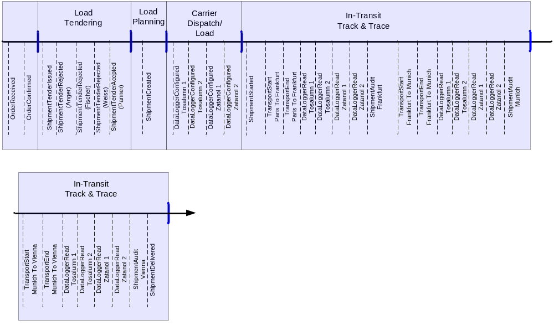
…
Figure 2: Storyline

297 Tosalumn
297 Tosalumn
1000 Zatanol
1000 Zatanol
1000 Zatanol
400 Tosalumn
OrderReceived.DeliveryDate
Transport Paris - Frankfurt
Transport
Frankfurt - Munich
…
OrderReceived
ShipmentAudit
ShipmentAudit
ShipmentAudit
Transport Munich - Vienna
Units found by shipment audit
Loss detected
Message to staffmember
continue shipment
if necessary: additional shipment with 103 units “Tosalumn”

